EYFS
W/C 18.05.20
Weekly Phonics:

- Your child is currently accessing Phase 4.
- Use www.phonicsplay.co.uk to access activities from Phase 1 to Phase 4. (Username: march20 Password: home)
- Continue to practise reading CCVC and CVCC words (use the phonics play games as appropriate).
- Revise the ‘or’ sound in words. To teach the sound, go to www.youtube.com and search for ‘Mr Thorne and the or sound’. To practise the sound go to www.phonicsplay.co.uk – Phase 3 Picnic on Pluto and choose ‘or’.
- Write a list of any words you can remember with the ‘or’ sound in them.
- Continue to use the flash cards to practise all the sounds and tricky words we know.

Writing: Jack and the Beanstalk
Writing:
- Remember you changed the character of the giant last week (perhaps to a teddy bear).
- This week I would like you to design and make your own house for you alternative character e.g. for the giant this was his castle.
- Start by drawing what you would like your alternative character’s house to look like.
- Using your design make your alternative character’s house using different materials e.g. cardboard, plastic bottles, bottle lids, wrappers.
- After you have finished your house think about some words you could use to describe the different parts of your house e.g. the door. Is it a red door, a huge door, a creaky, old door?
- Write labels to stick on your model house.
- Why is it a great house for your character?

Reading:
- Use My Rising Stars website, log in to read your allocated books and attempt the activities/quizzes at the end. (These will be changed weekly)
- Again place a teddy bear somewhere were your child will find it and put on a new sign. ‘I’m happy. Please read me a funny story’. Encourage your child to share a favourite book that makes them laugh with the teddy.

Maths Skills:
- Explore time this week. Perhaps you could make a clock with a paper plate. Begin to look at o’clock times.
- Make a timetable for the day and draw pictures to show what you will be doing at 8 o’clock, 10 o’clock etc.
- Practise counting back from 20 starting from any number. www.youtube.com Counting down from 20 song.
- www.10ticks.com - use password provided to access

Other:
Physical
- Play ‘What’s the time Mr Wolf’ with your child. Lots of running and squealing will be involved.

Knowledge and Understanding of the World
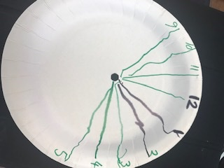
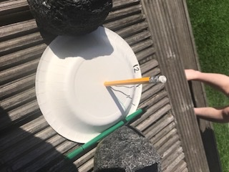
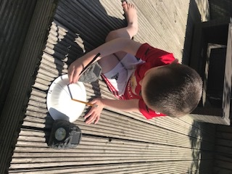
- This week we are going to explore sunshine. (I’ve looked at the weather and I’m hopeful). Did you see this post by Mrs McCarthy on twitter? Could you make a paper plate sundial and mark on the hours. Watch how the shadow moves. This is a good opportunity to talk about night and day.
- If you have some chalk, let your child try drawing around your shadow. Make some funny shapes.
- Play chases and try to jump on each other’s shadows. Talk about why we see a shadow.
- Watch the you tube clip from the Peter Pan film. https://www.youtube.com/watch?v=bH6N1A4fwcs
and talk about why we can’t lose our shadow!
Creative
- I hope you’ve enjoyed making spirals. Can you now explore using natural materials to create spirals? (See examples below). What else can you find in your garden to make or draw a spiral? Can you make a repeating pattern using the natural materials.

