Year Two
W/C 18.05.20

Weekly Phonics:
- This week we are going to revise adding the suffix – ing to words.
- Revise the rules for adding -ing by playing www.phonicsplay.co.uk – Phase 6 Tumbling Tumbleweed (Username: march20 Password: home).
- Practise adding the ‘ing’ suffix to these words roll, jog, walk, write, eat, trade, skate, work, clean, wave
- Use www.spellingshed.com to practise spellings.

Writing: Jack and the Beanstalk
- Drama – Take turns to pretend to be different characters from the story. What might Jack’s mum say when he returns home with beans? What might Jack say as he reaches the bottom of the beanstalk with the giant chasing him? You could dress up as each character to help you get into role.
- Pretend you are Jack and write a diary entry about what has happened to you over the last few days. You could start with:

Dear Diary,

You will not believe what has happened to me!

Reading:
- Use your My Rising Stars website log in to read your allocated books and attempt the activities/quizzes at the end.

Maths Skills:
- Continue to explore volume this week. Use a kitchen jug to measure 100 millilitres, 200 millilitres, a litre of water etc..
- Perhaps you could follow a recipe that requires measuring in millilitres e.g. making Angel Delight or a chocolate milkshake.
- www.ttrockstars.com
- www.10ticks.com - use password provided to access

P.E.
- Let’s Get Moving with Les Mills workouts ‘Born to Move’ https://www.lesmills.com/uk/workouts/kids-classes/born-to-move-8-12-years/
There are a variety of activities including dance and combat sessions.
Geography
- This week we are looking at extreme weather.
- Use construction sets e.g. to build several houses until you have got a village.
- Place the houses in a plastic box or the bath and put sponges between the houses. Slowly pour water onto the sponges.
- Ask what do you think might happen?
- When the sponge is full of water it will start to overflow and then flood around the houses. Explain to the children that this shows why there was so much flooding earlier in the year. The ground usually soaks up the rain, when it rains too much the ground can’t soak up any more rain and then rain sits on top of the ground as floods.
- Show video – www.youtube.co.uk Why do floods happen? Scishow kids (just show the first two minutes).
- Discuss why is flooding so dangerous

Science
- Please help me! I have a spider plant that does not look very well. Remember what you have learned about plants and please write me a letter, to explain how I should look after my plant.
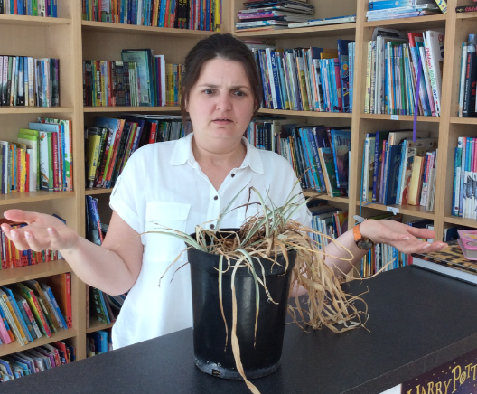

D&T/Art
- Be a landscape artist! Go outside and find a nice view or spot to draw or paint. Remember to look at the detail carefully.

