Maths | To work on the unit of ‘Length’. This is Chapter 5 in textbook 3A. If you are still working on the unit of ‘Time’, please carry on with this and don’t feel rushed to move on. Work at your own pace and work through it in a way that gives you the best understanding.  If you need any further resources to support Maths, the white rose maths website (www.whiterosemaths.com) has some excellent resources and demonstrates a range of questions that deepen understanding as well as each unit being broken down so it is easy to follow.  TT Rockstars and 10ticks.com are all set up for your child to access and to revises basic maths skills. | - One lesson of maths each day is a suggested amount. You would need to begin by working through the textbook, as there are questions and tasks in there, before completing the workbook. Begin, on day 1, with lesson 1 and worksheet 1.  - Daily lessons are available via the BBC Bitesize website which are brilliant. If you miss any, they can be found on BBC iPlayer.
English  (Including reading) | This week for English, I would suggest continued practise on with our online resources. | - Continued practise on Spelling Shed  - Read and answer questions for text set on Rising Stars – questions are designed to be completed alongside the book.  - For a writing task this week, I would focus on writing setting descriptions. You could choose any setting; it could be a forest, city, magical woodland or a mountain range. I would then create a descriptive paragraph about that setting in detail. Describe each part of the scene, compare it to other things, describe how it makes you feel being within the scene.  - https://www.literacywagoll.com/settings.html have some great examples to look at.
R.E. | In R.E. this term, we would be looking at the unit of Encounters. | This week I would focus on a Church and base the week around Christianity. It would be good to look closely at a church as a sacred space and understand the layout, artefacts and symbols used within a church. If you have a church close, it may be an idea to have a walk to the church and take a look around the grounds and notice the any external features (I know it’s difficult as you won’t be able to go inside).
French | This week for French, I would suggest practising on an online resource or app. | Duolingo (a free app available on the app store or at https://www.duolingo.com/) is a great app to keep learning French independently.
P.E. | It is so important to keep active during this time not just for physical health but it is also fantastic for mental wellbeing. | - Joe Wicks is continuing to hold his online HIIT sessions via his youtube channel. These can also be accessed on his YouTube channel after they have been filmed live.  - Oti Mabuse is holding daily dance classes live on her Facebook and Instagram at 11:30am. These can also be accessed on her YouTube channel after they have been filmed live.
Art | For Art, we are focussing on Greek vases and how they are used to tell a story as well as having a purpose within everyday life. | 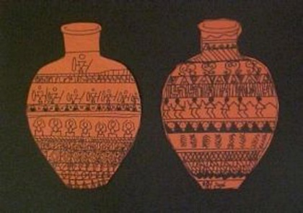  If you have already designed your Greek vase, why don’t you have a go at making it? This could be out of recycled material, modelling clay (play-doh), papier-mâché or you could do it on paper like the picture below.  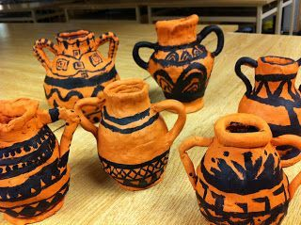
Science | In Science, our unit is ‘Sound’. | This week, I would learn about how we hear sound. How does the ear work and the parts within the ear? Twinkl have a great worksheet on the link below:  https://www.twinkl.co.uk/resource/t3-sc-814-the-ear-cut-and-stick-activity-sheet  https://www.twinkl.co.uk/resource/parts-of-the-ear-powerpoint-us2-s-369 - this is a Power point that complements the worksheet above.

