EYFS
W/C 11.05.20
Weekly Phonics:

- Your child is currently accessing Phase 4.
- Use www.phonicsplay.co.uk to access activities from Phase 1 to Phase 4. (Username: march20 Password: home)
- Continue to practise reading CCVC words (This week try Picnic on Pluto on phonics play and choose the appropriate section).
- Practise recognising and reading the ‘ur’ sound in words. To teach the sound, go to www.youtube.com and search for ‘Mr Thorne and the ur sound’. To practise the sound go to www.phonicsplay.co.uk – Phase 3 – Make a Match Phase 3 – or, ur, ow, oi (the one with the dragon).
- Make flashcards to play your own memory game using ‘ur’ words e.g. burn, curl, turn, church, burp, turtle, fur
- Continue to use the flash cards to practise all the tricky words we know.

Writing: Jack and the Beanstalk
- Writing: Use whatever resources you can lay your hands on, to create a model of the story of Jack and the Beanstalk (alternatively you could paint or draw a picture). Use the model to retell the story and then encourage your child to use sounds to label all the different parts of the model e.g. Jack, cow.
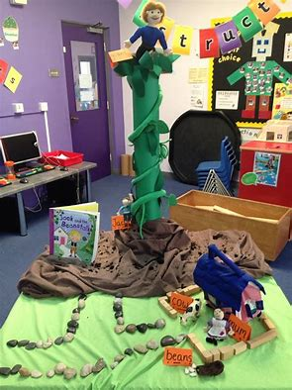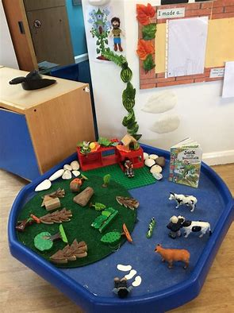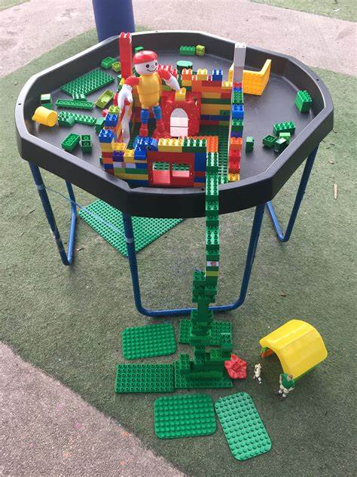
- Try changing one of the characters in your model e.g. change the giant into a teddy bear. What might the teddy bear say when Jack climbs the beanstalk?
Reading:
- Use My Rising Stars website, log in to read your allocated books and attempt the activities/quizzes at the end. (These will be changed weekly)
- Place a teddy bear somewhere were your child will find it and place a sign on it that says, ‘I am sad. Please read me a story’. Encourage your child to share a favourite book with the teddy.

Maths Skills:
- Explore volume this week. Use a paddling pool, the kitchen sink or bath time to allow children to fill and empty containers with water. Encourage them to use the vocabulary – full, half full and empty. How many cups of water do they think they will need to fill a larger container? Which container do they think will hole the most cups of water? Just have fun with this! You will probably get wet!
- Practise counting on forwards to 20 from any number. www.youtube.com Counting on by 1’s/ I Can Count From Any Number (Numbers 1-20) Jack Hartmann.
- www.10ticks.com - use password provided to access

P.E.
- Encourage your child to think of lots of different physical activities to do outside e.g. run around the garden, catch a ball, bunny hop, go down the slide etc… Have a competition with family members – Who can do each activity the most times in a minute?

Other:
- This week we are looking at the weather. Which way is the wind blowing? How do you know? Explore the wind by blowing bubbles and watching which way they blow. Use an old plastic bag and some string to make your own kite. When does your kite fly really well? You could make your own windsock, go to www.wikihow.com/Make-a Windsock-for-children for instructions on how to make a plastic windsock.

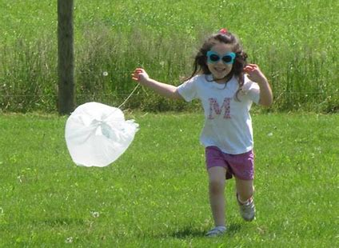

- We are still looking at plant growth. Have a look around the garden, can you find any dying daffodils? Discuss what has happened to the daffodil. If you can, dig up a daffodil bulb so that you children can get a better understanding of how a bulb works and is different to a seed.

- Continue to explore spirals by creating your own patterned spiral snake. You could make this into a puppet.
