EYFS
W/C 4.05.20
Weekly Phonics:

- Your child is currently accessing Phase 4.
- Use www.phonicsplay.co.uk to access activities from Phase 1 to Phase 4. (Username: march20 Password: home)
- Practise reading CCVC words (Try Buried Treasure on phonics play and choose the appropriate section). Try writing some words yourself and ask your child to draw on sound buttons and then attempt to write the words themselves.
- Play a musical round game with your child. Put a selection of CCVC words in a bag and pass around until the music stops. If they are holding the bag let your child remove a word and win a point for reading it correctly. Bonus point if they can put the word in a sentence. Let them play against a puppet or soft toy which can make silly mistakes!
- Continue to use the flash cards to practise all the tricky words we know.

Writing: Jack and the Beanstalk
- Make a postcard by drawing a fabulous picture on one side of a piece of card or you will find a blank postcard template on twinkl to print if you would like.
- Talk about what you think Jack should say to the Giant in our story.
- Plan and write the postcard together, encourage Oliver to listen to the sounds in each word and record the sounds he knows, he can refer to an alphabet strip for the sounds he is unsure of, or someone else can record these sounds for him.
Reading:
- Use My Rising Stars website, log in to read your allocated books and attempt the activities/quizzes at the end. (These will be changed weekly)
- A selection of books has been provided. Read daily and talk about the book. Encourage your child to ask questions.
Number Skills:
- Set up a tea party for a selection of teddies. Give your child different numbers of raisins (or other food) to share between their teddies. Can they share equally? Give them a number which will not share equally and see if they can spot the problem.
- Encourage your child to record what they have done or found out.
- Practise number formation.
- www.10ticks.com - use password provided to access

P.E.
- Why not build an obstacle course around your house and garden. Time your child and then see if they can improve on their time. Make changes and improvements as the week progresses.

Other:
This term we are looking at plants and growing.
- Can you find a snail in your garden and look closely at the shell. Try drawing or painting a spiral. Here are some ideas for you.
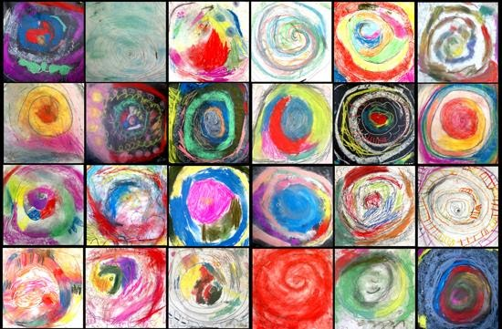
- Look around your garden for signs of spring. What changes can you spot?
- If you have any bean seeds at home, you could set up an experiment to watch a bean growing. https://www.youtube.com/watch?v=pg92cspLy0I
- This you tube video using time lapse photography is a good alternative if you don’t have any seeds. https://www.youtube.com/watch?v=w77zPAtVTuI
- You could make a bean diary with labelled pictures to show what happens to your bean each day.

