EYFS
w.b. 27.04.20
Weekly Phonics:

- Your child is currently accessing Phase 3, moving on to Phase 4.
- Use www.phonicsplay.co.uk to access activities from Phase 1 to Phase 4.
- This week practise sh – use www.spellingshed.com to practise. Spelling lists will be changed weekly.
- www.youtube.com Watch Mr. Thorne does phonics – sh and Geraldine Giraffe learns sh.. Use the whiteboard and pen to write the words shown and draw on sound buttons. Can he read each word?
- www.youtube.com Tricky Words and Sight Words Song
Phase 3 Tricky Words Song Say Hello To

- Writing: Use whatever resources you can lay your hands on, to create a model of the story of Jack and the Beanstalk. Use the model to retell the story and then encourage Oliver to use his sounds to label all the different parts of the model e.g. Jack, cow.
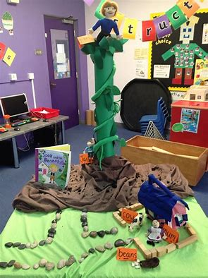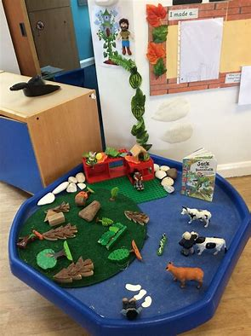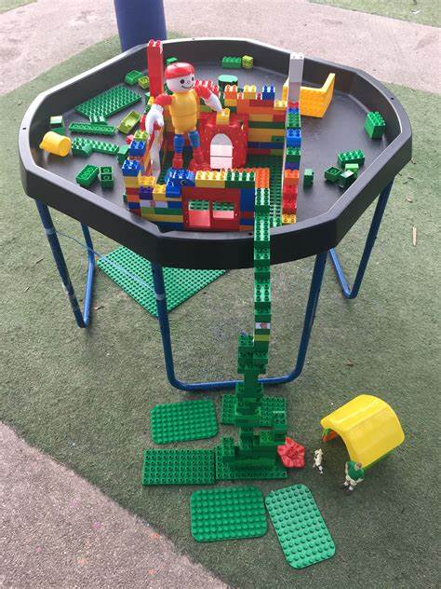

Reading:
- A selection of books has been provided. Read to Oliver and encourage him to ask you questions about what you have read. New books have been assigned on Rising Stars Reading Planet

Maths Skills:
- Measure – Ask Oliver to collect 10 of his favourite teddies. Which is the largest/smallest? Which is the tallest/shortest? Can he order them in height order?
- Counting challenge! How many times can you write your name in a minute? How many times can you run around the garden in a minute? Etc…
- Continue to practise recognising, ordering and counting out sets to match numbers from 0 to 20.
- Use buttons to add two small groups together e.g. 3+2 (practise this on www.10ticks.com)
- Count forwards to 20.
- www.youtube.com Jack Hartman: Count to 20 and workout
NumberJacks – One More Time

Other:
- P.E Joe Wicks will be doing daily workout sessions at 9 o’clock on his you tube channel.
- Challenge! Can Oliver ride a bicycle?
- Leaf hunt – Can Oliver find 20 different leaves? Discuss the different shapes and sizes, create leaf rubbings.
D&T/Art
- Go outside and find a snail, or look online. Look at a snail’s spiral.
- On a piece of paper draw your own spiral and use different colours either colouring pencils, paint to colour in your picture. For inspiration look at some of the pictures below.

