Year One
w.b. 20.04.20
Weekly Phonics:
- Your child is currently accessing Phase 5.
- Use www.phonicsplay.co.uk to access activities from Phase 2 to Phase 5
- This week practise tch – use www.spellingshed.com to practise.
- www.youtube.co.uk tch for ch – Mr Thorne does phonics

Writing:
- Our new book is Jack and the Beanstalk – What can your child already tell you about the story? Read Jack and the Beanstalk or watch a version of the story on www.youtube.co.uk .
- Make props to act out the story of Jack and the Beanstalk with your family.
- Draw a story mountain or story map and use it to retell the story to your family or your teddies. Pick one part of the story e.g. opening, build-up, problem, resolution or ending and write that part in your exercise book. Remember to include adjectives (describing words) and the conjunction ‘and’.
Reading:
- A selection of books has been provided. Read your child’s own books to them. Can they ask you a question about each page read? New books have been assigned on Rising Stars Reading Planet.
Number Skills:
- Know number pairs to 10 by heart. E.g. 4+6=10, 2+8+=10 www.youtube.com I Can Say My Number Pairs 10 / I Know my Number Bonds with DJ Count http://www.ictgames.com/saveTheWhale/
- Use the clocks provided to tell the time to the hour and half hour. Use the login provided to access www.mathsnoproblem.com Have a go at Textbook and Workbook 1B, Chapter 16 – Time
- www.youtube.com Jack Hartman: Count to 100
- www.10ticks.com - passwords sent via classdojo

Other:
- P.E Joe Wicks will be doing daily workout sessions at 9 o’clock on his you tube channel.

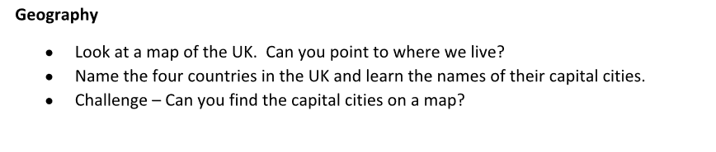
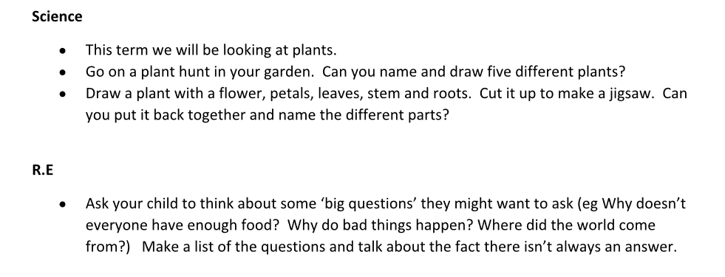
Art

- Link our previous work to our new topics by creating large images of plants and flowers outside using natural materials, in the style of Andy Goldsworthy.

