Year Two
w.b. 20.04.20
Weekly Phonics:
- Your child is currently accessing Phase 6.
- This week practise the ‘s’ sound but spelled ‘c’ before e, i and y – use www.spellingshed.com to practise. Spelling lists will be changed weekly.
- www.youtube.co.uk Soft C – Mr Thorne does phonics and Geraldine Giraffe learns soft c.
- Use the whiteboard and pen to write the words shown and draw on sound buttons. Can they read each word?
- Use www.phonicsplay.co.uk to access activities from Phase 4 to Phase 6. This week play – Phase 5 – Cheeky Chimps – C.
Writing:
- Our new book is Jack and the Beanstalk – What can your child already tell you about the story? Read Jack and the Beanstalk or watch a version of the story on www.youtube.co.uk .
- Make props to act out the story of Jack and the Beanstalk with your family.
- Draw a story mountain or story map and use it to retell the story to your family or your teddies. Pick one part of the story e.g. opening, build-up, problem, resolution or ending and write that part in your exercise book. Remember to include adjectives (describing words), conjunctions (when, because, if, that) and different types of punctuation.
Reading:
- A selection of books has been provided. Read your child’s own books to them. Can they ask you a question about each page read? New books have been assigned on Rising Stars Reading Planet.

Number Skills:
- Use coins to keep practising counting in steps of 1, 2, 5 and 10. E.g. If I have 7 five pence coins, how much money do I have?
- Use the clock provided to practise counting in steps of 5 around the clock.
- Use the login provided to access www.mathsnoproblem.com Have a go at Textbook and Workbook 2B, Chapter 14 – Time
- Know number pairs to 10 by heart. E.g. 4+6=10, 2+8+=10 http://www.ictgames.com/saveTheWhale/
- www.ttrockstars.com – use password provided
- www.10ticks.com - passwords sent via classdojo

- Other: P.E Joe Wicks will be doing daily workout sessions at 9 o’clock on his you tube channel.
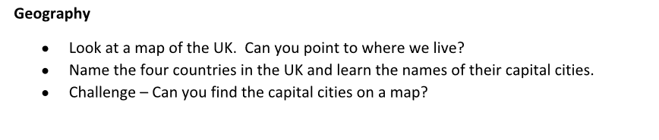
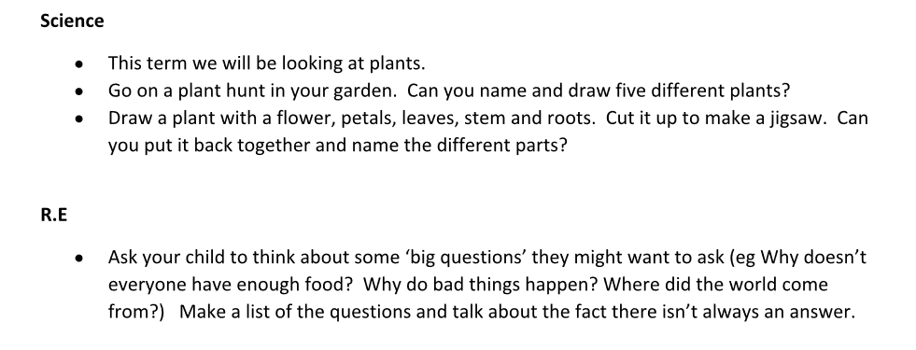

Art

- Link our previous work to our new topics by creating large images of plants and flowers outside using natural materials, in the style of Andy Goldsworthy.

